Phone-Tree Menu Design

Aim
To show how to build a Phone-Tree Menu / IVR incorporating the Nielsen Phone-Tree System Usability Guidelines in mind.

Design
The image below provides a broad overview of the intended IVR.
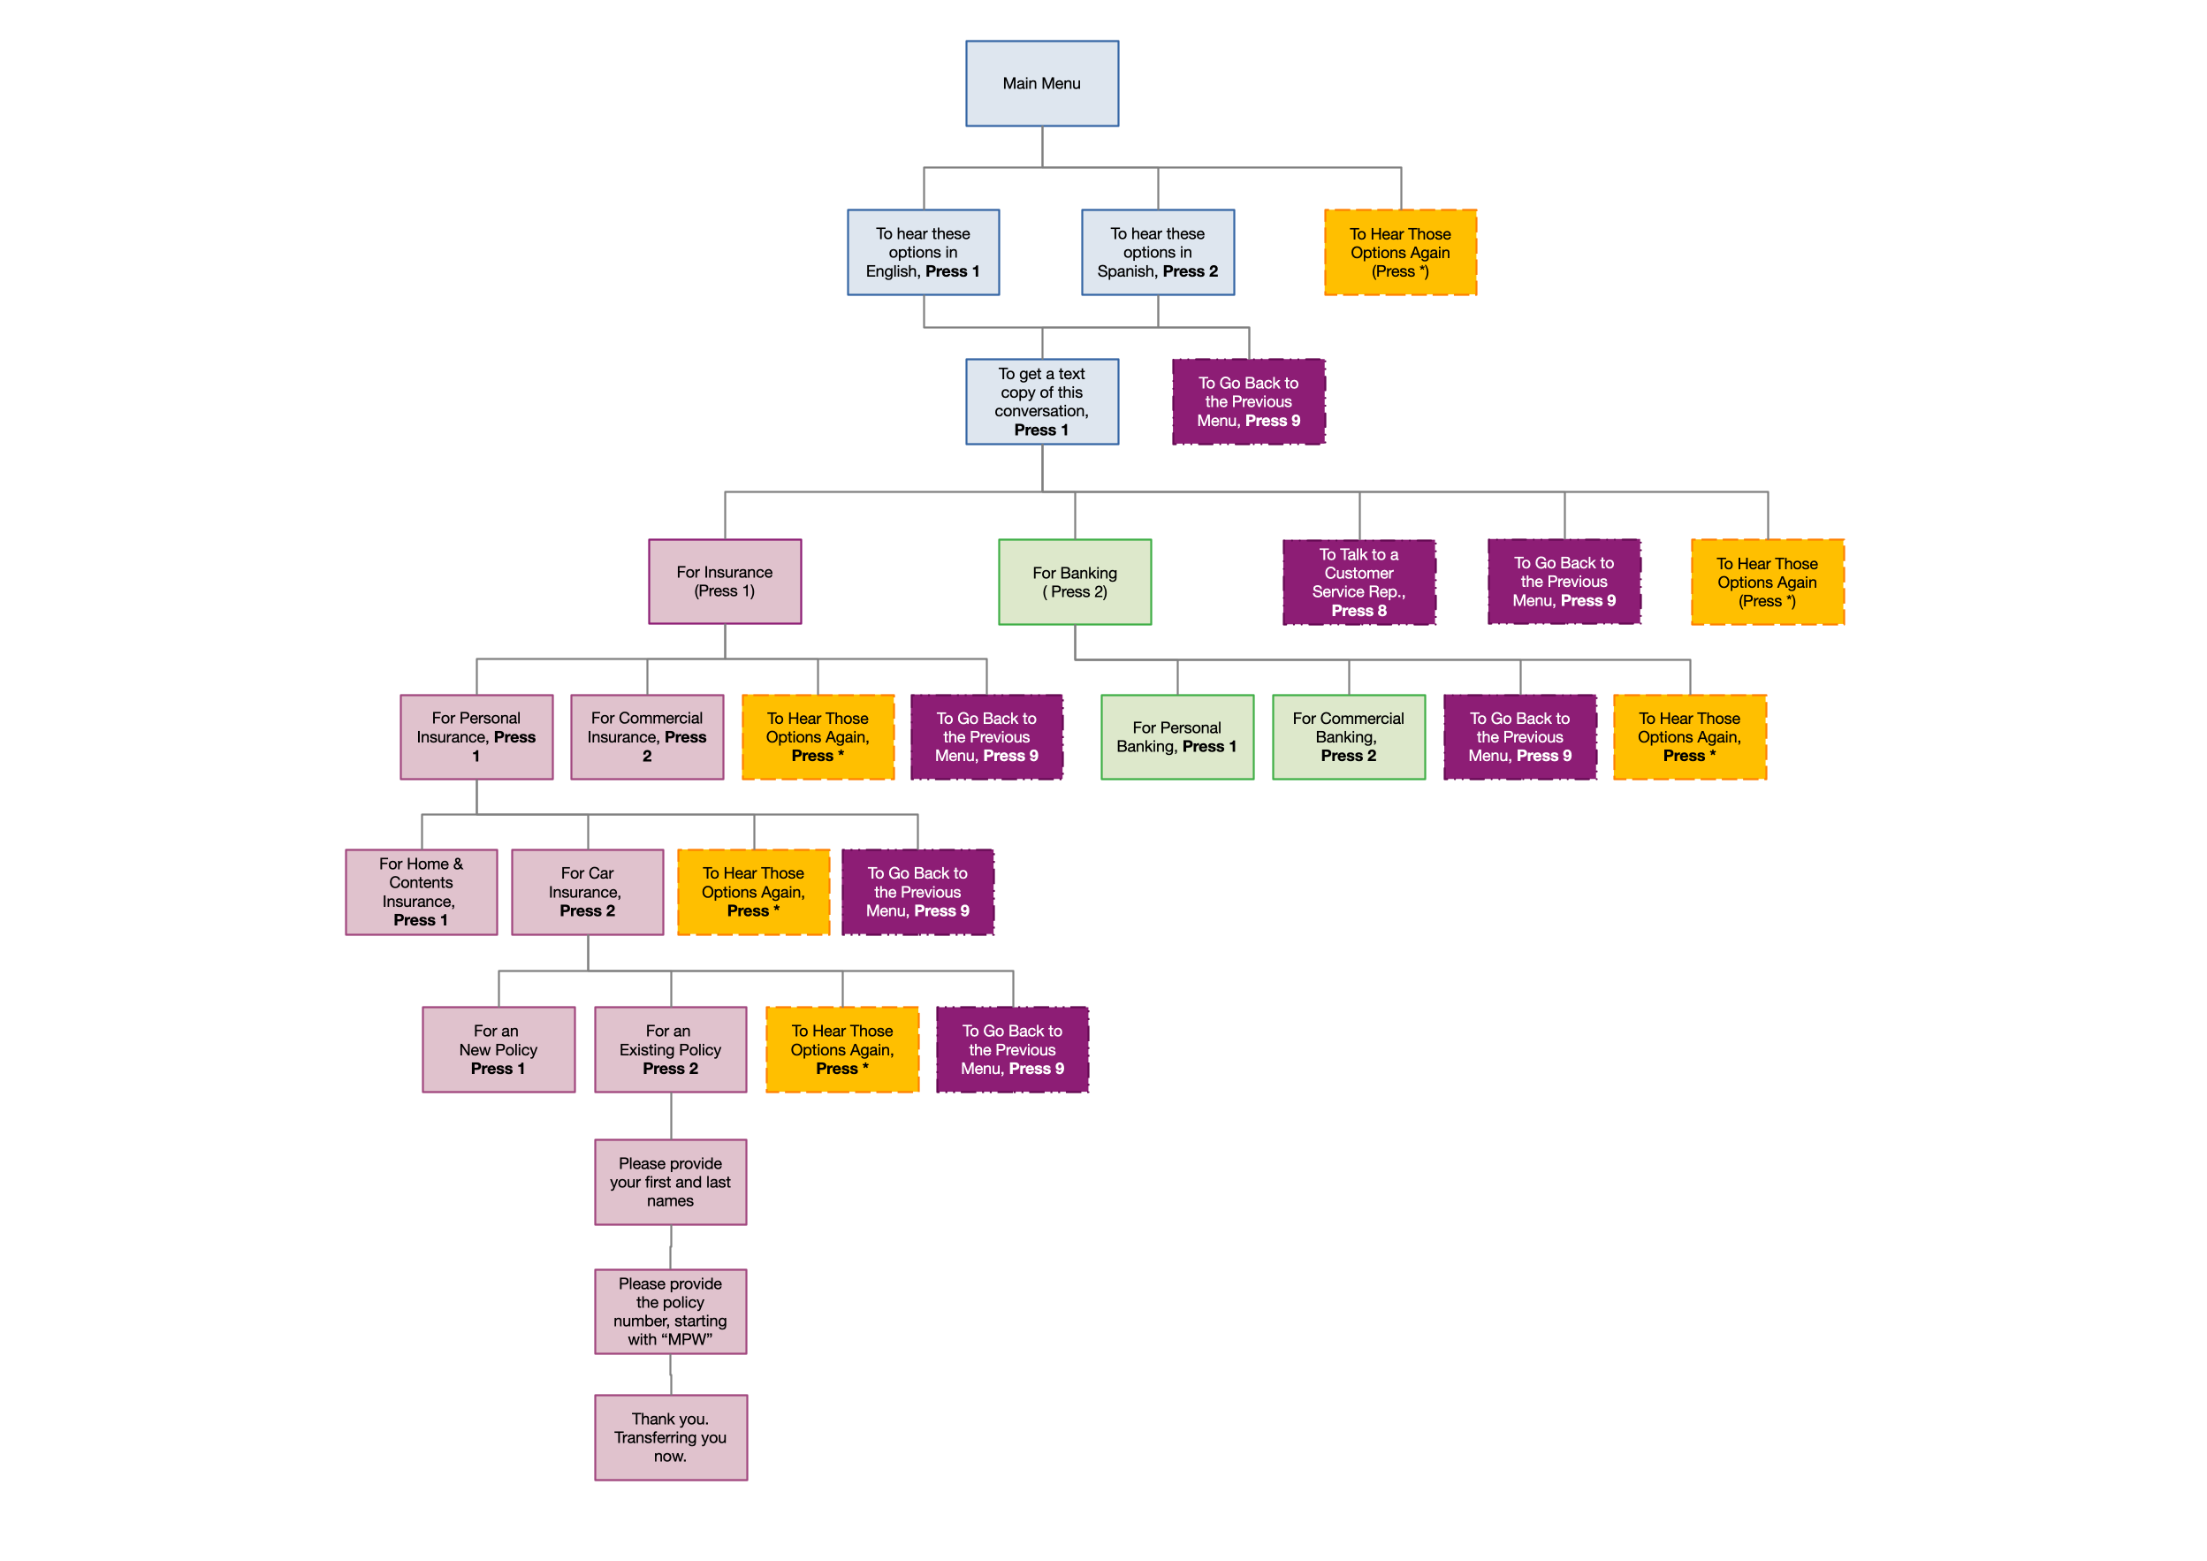

How Will It Be Implemented?
The application will be implemented with PHP and Twilio, using TwiML for Programmable Voice. The TwiML verbs required by the application are: Gather, Hangup, Pause (possibly), Play or Say, Record, Redirect, and Transcription.

The following options are reserved throughout the IVR:
- *: Pressing this starts playing the current level’s options again
- 8: Takes the customer through to the next available customer service representative
- 9: Takes the caller back to the previous level
- #: Confirms user input

